Joining the Constituency Action Network

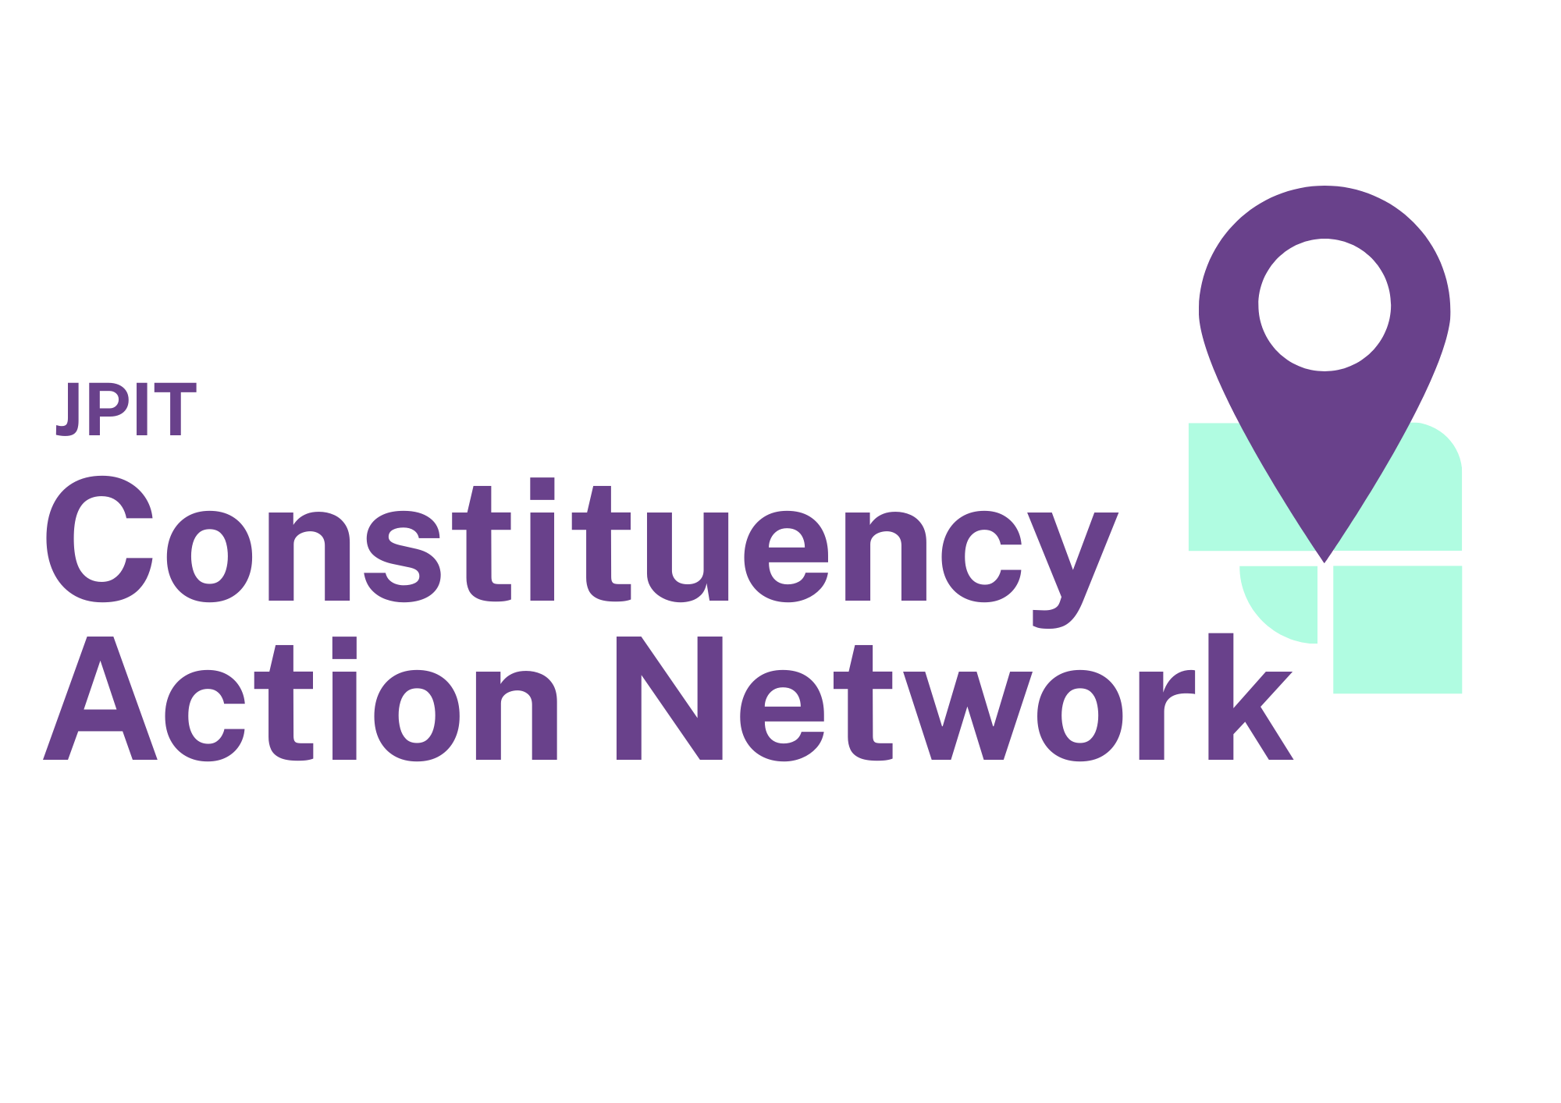

Contents
What is the Constituency Action Network? 2
Baptist churches 3
Methodist churches 5
United Reformed Church congregations 7
Church of Scotland 8
Other denominations 9

What is the Constituency Action Network?
The Joint Public Issues Team’s Constituency Action Network (CAN) is a network of churches across the UK who are committed to building a meaningful relationship with their MP and working with them to speak and act for peace and justice. The goal is to develop a network in which there is a church in every Westminster constituency (in England, Scotland and Wales) that is actively involved with their MP.
Each congregation will agree to pray for their MP and develop a positive relationship with them through meetings, letters, meals, offers of support etc. The Joint Public Issues Team (JPIT) will provide training, tailored information on current campaigns and give advice on what to ask the local MP.
Is there a cost?
It's important to note that the network is free to join! The administrative costs of running the network are borne by the Baptist Union of Great Britain, Methodist Church and United Reformed Church, who partner together in seeking justice through the Joint Public Issues Team (JPIT). The Church of Scotland is an associate member of JPIT and also part of CAN.
Who is CAN for?
The network is intended for entire church congregations or church partnerships such as Local Ecumenical Partnerships (LEPs) to participate in together. If your church or congregation’s denomination or network is not part of JPIT’s ecumenical partnership you are still welcome to join, but our resources will be written with our member denominations and networks in mind. As each of our denominations has slightly different decision-making structures (and your church congregation might have its own specific approach), we have given advice by denomination below:


Baptist churches
- Determine Your Role in Coordinating CAN
You will need to decide if you will take on full or partial responsibility for coordinating CAN activities within your church. If needed, consider recruiting someone else to assist you.
- Seek Support from Church Leadership
Approach the minister, church secretary, or another suitable leader to discuss the benefits of joining CAN:
  - You might want to email them with the ‘What is CAN’ PDF, or point them to the webpage: (jpit.uk/can) to explain why you think it would be a good idea to join.
  - If you are the minister/church secretary/leader, please do consult with another appropriate member of the church’s leadership team.
- Request Leadership Approval
If the minister/church secretary/leader consents, ask if they would take it to the next Leadership/Deacons/Elders Meeting.
  - Sending each of the leaders a copy of the ‘What is CAN’ PDF, the CAN agreement or a link to the webpage (jpit.uk/can) will help them understand more about the network before the meeting.
- Plan for a Congregational Discussion and decision making
If the leaders are happy to commend CAN to the church congregation/membership, ask for it to be scheduled in the next possible Members Meeting (or a similar gathering).
  - Decide with the minister/church secretary/leader if you or someone else should present to the congregation.
  - You (or whoever is presenting) might wish to use the ‘What is CAN’ PowerPoint in the meeting.
  - The congregation should be asked to agree to the CAN agreement
  - You are also encouraged to ask if other church members would like to form a small CAN coordination team.
- If the members agree to the proposal, then congratulations! Please send a signed version of the CAN agreement to enquiries@jpit.uk
If there are any issues or concerns, do let us know so we can help answer them.

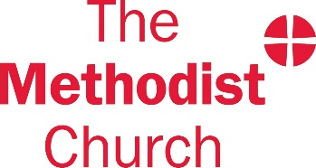
Methodist churches
- Determine Your Role in Coordinating CAN
You will need to decide if you will take on full or partial responsibility for coordinating CAN activities within your church. If needed, consider recruiting someone else to assist you.
- Seek Support from Church Leadership
Approach the minister, a Steward, or another suitable leader to discuss the benefits of joining CAN:
  - You might want to email them with the ‘What is CAN’ PDF attached, or point them to the webpage²: (jpit.uk/can)
  - If you are the Minister or Steward, please do consult with another appropriate member of the church’s leadership team.
- Request Leadership Approval
If the Minister or Steward or another member of your church’s leadership team consent, ask if they would take it to the next stewards meeting of leadership team meeting.
  - Sending each of the leaders a copy of the ‘What is CAN’ PDF, the CAN agreement or, a link to the webpage (jpit.uk/can) will help them understand more about the network before the meeting.
- Plan for a Congregational Discussion and decision making
If the Stewards or leadership team are happy to commend CAN to the
Church congregation/membership, ask for it to be proposed to the next
Church Council meeting.
  - Decide with the minister/stewards if you or someone else should present to the congregation.
  - You (or whoever is presenting) might wish to use the ‘What is CAN’ PowerPoint in the meeting.
  - The Church Council should be asked to agree to the CAN agreement
  - You are also encouraged to ask if other church members would like to form a small CAN coordination team.
- If the Church Council agrees to the proposal, then congratulations! Please send a signed version of the CAN agreement to enquiries@jpit.uk
If there are any issues or concerns, do let us know so we can help answer them.

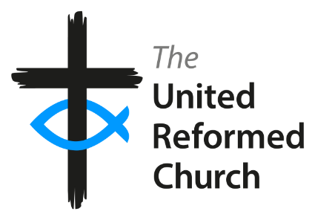
United Reformed Church congregations
- Determine Your Role in Coordinating CAN
You will need to decide if you will take on full or partial responsibility for coordinating CAN activities within your church. If needed, consider recruiting someone else to assist you.
- Seek Support from Church Leadership
Approach the minister or Elder to discuss the benefits of joining CAN:
  - You might want to email them with the ‘What is CAN’ PDF attached, tor point them to the webpage²: (jpit.uk/can)
  - If you are the minister/an elder, please do consult with another elder.
- Request Leadership Approval
If the Minister or Elder consents, ask if they would take it to the next Elder’s meeting of leadership team meeting.
  - Sending each of the Elders a copy of the ‘What is CAN’ PDF, or a link to the webpage (jpit.uk/can) will help them understand more about the network before the meeting.
- Plan for a Congregational Discussion and decision making
If the Elders are happy to commend CAN to the
church congregation, ask for it to be proposed to the next
Church meeting.
  - Decide with the minister/elders if you or someone else should present to the congregation.
  - You (or whoever is presenting) might wish to use the ‘What is CAN’ PowerPoint in the meeting.
  - The congregation should be asked to agree to the CAN agreement
  - You are also encouraged to ask if other church members would like to form a small CAN coordination team.
- If the members agree to the proposal, then congratulations! Please send a signed version of the CAN agreement to enquiries@jpit.uk
If there are any issues or concerns, do let us know so we can help answer them.


Church of Scotland
The Church of Scotland is an associate member of JPIT, meaning they share information and ideas, and work with JPIT on initiatives and campaigns that have relevance to Scotland. These are agreed on a project-by-project basis.
- Determine Your Role in Coordinating CAN
As an individual, you will need to decide if you will take on full or partial responsibility for coordinating CAN activities within your church. If needed, consider recruiting someone else to assist you.
- Seek Support from Church Leadership
Approach the Minister or an Elder to discuss the benefits of joining CAN.
You might want to email them with the ‘What is CAN’ PDF attached, the CAN agreement or point them to the webpage: (jpit.uk/can)
- Take CAN to the next Kirk Session
If the Minister or Elder consents, ask if they would take it to the next Kirk Session for decision.
They might wish to use the ‘What is CAN’ PowerPoint in the meeting.
The Kirk Session should be asked:
- To read the CAN agreement
- Are we willing to join the Constituency Action Network, to commit to listening to the needs of our neighbourhood and praying for and developing a relationship with our MP?
If agreed, you are also encouraged to ask if volunteers from the congregation would like to form a small CAN coordination team.
If your Kirk Session agrees to sign up to CAN, then congratulations! Please send a signed version of the CAN agreement to enquiries@jpit.uk
If there are any issues or concerns, do let us know so we can help answer them.

Other denominations
We trust that you know your church structure much better than we do. Feel free to take what advice is helpful for your context. A suggestion of some steps may be:
- Determine Your Role in Coordinating CAN
As an individual, you will need to decide if you will take on full or partial responsibility for coordinating CAN activities within your church. If needed, consider recruiting someone else to assist you.
- Seek Support from Church Leadership
Approach someone in an appropriate position of leadership in your church to discuss the benefits of joining CAN and ask permission to take CAN to the wider church.
You might want to email them with the ‘What is CAN’ PDF attached, or point them to the webpage: (jpit.uk/can)
- Discuss CAN with your church
If the leaders are happy to commend CAN to the church congregation/membership/church, ask for it to be scheduled in the next possible meeting (or a gathering).
  - You (or whoever is presenting) might wish to use the ‘What is CAN’ PowerPoint in the meeting.
  - The congregation should be asked to agree to the CAN agreement
  - You are also encouraged to ask if other church members would like to form a small CAN coordination team.
- If the congregation/members agree to the proposal, then congratulations! Please send a signed version of the CAN agreement to enquiries@jpit.uk
If there are any issues or concerns, do let us know so we can help answer them.

Worshipping congregations that meet in Christian institutions, such as Theological or Ministerial Colleges, are considered to be churches for the purposes of CAN.
A printer copy is available on request

